***NAME : Himanshu Dixit***

***ENROLL NO. : 21103262***

***BATCH : B10***

***Software Development fundamentals-2 [EVEN 2022]***

***Tutorial Sheet -9 (Week 9)***

***1.*** *Write a program using exception handling for a voting system. Take age from user. If age is greater than 18, display the following message.*

***Enter age 18***

***Access granted - you are old enough.***

*Else print following message using exception handling.*

***Enter age 16***

***Access denied - You must be at least 18 years old.***

***Age is: 16***

***Solution:***

#include <iostream>

using namespace std;

int main()

{

int age;

try

{

cout<<"Enter Age : ";

cin>>age;

if(age<18)

throw age;

cout<<"Access granted - you are old enough.";

}

catch(int i)

{

cout<<"Access denied - You must be at least 18 years old.\nAge is : "<<i;

}

return 0;

}

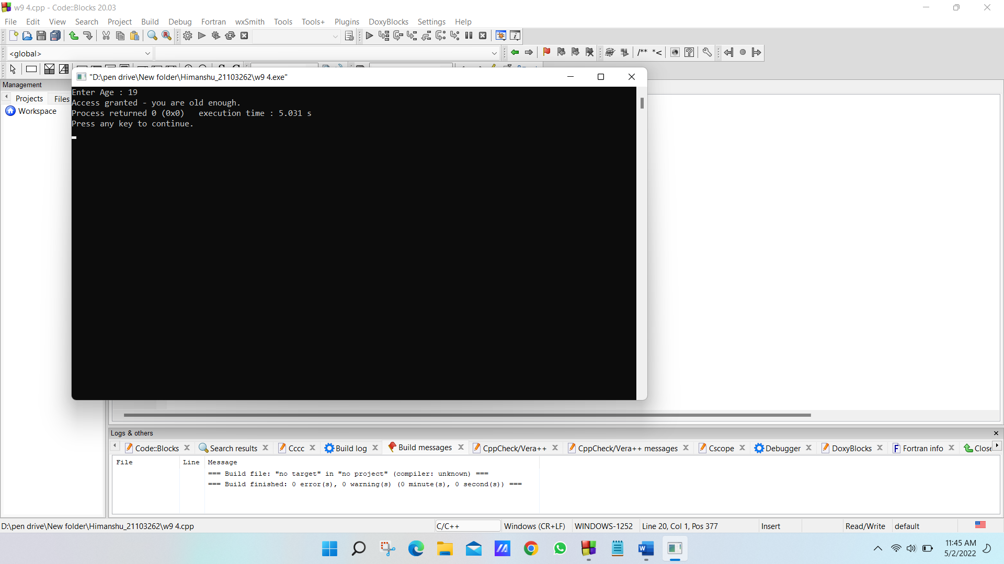

***2.*** *Write a program using exception handling that throws a division by zero exception. Catch the exception catch in the catch block. Create a function named zeroDivision that takes two integer arguments, x, and y. The function should return a double result. Use the try statement to catch an exception. Call the zeroDivision function and passing to arguments a. Catch the exception. The returned error message will be stored in the variable message. The program should return a value upon successful execution. Print out the returned error message on the console.*

***Solution:***

#include <iostream>

using namespace std;

double zeroDivision(double x, double y)

{

return (x/y);

}

int main()

{

int x,y;

try

{

cout<<"Enter two number : ";

cin>>x>>y;

if(y==0)

throw "Division is not possible(y=0)";

double ans = zeroDivision(x,y);

cout<<"x / y = "<<ans;

}

catch(const char *s)

{

cout<<s;

}

return 0;

}

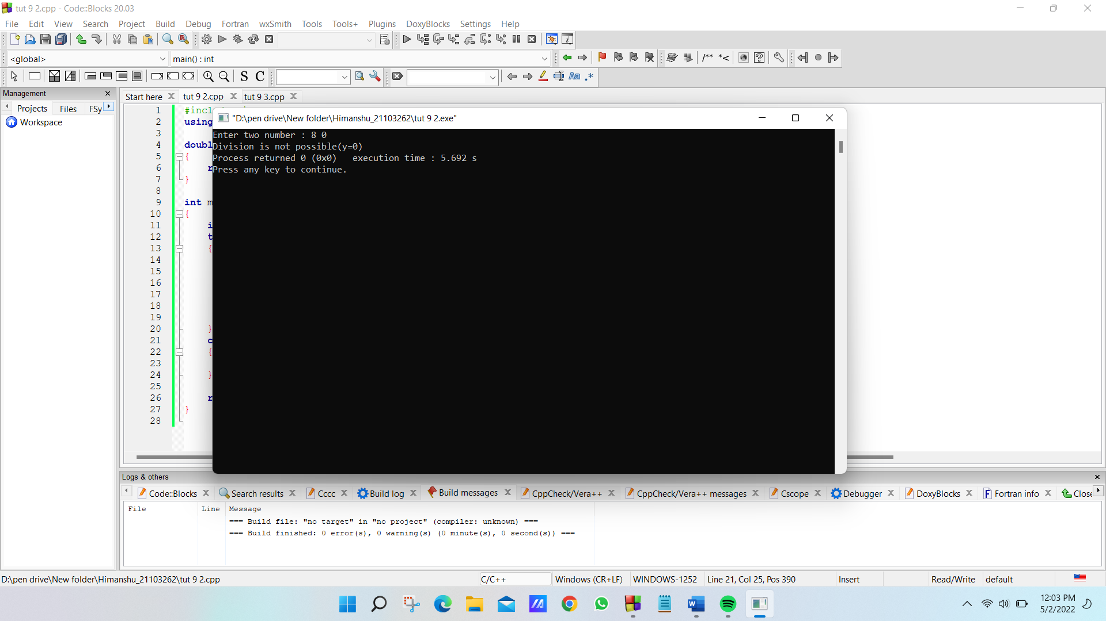

***3.*** *The harmonic mean of two numbers is defined as the inverse of the average of the inverses. The harmonic mean h(x,y) of two numbers x and y is given as*

*ℎ(x, y) = 2 × x × y*

*(x + y)*

*Write a program to find the harmonic mean of two numbers. Note that if y is the negative of x, this formula results in division by zero. If a user enters such combination of numbers, the exception should be handled with the appropriate message to the user and next set of numbers should be asked to enter.*

***Solution:***

#include <iostream>

using namespace std;

void harmonicmean(double x, double y)

{

if(y == -x)

throw 0;

cout<<"Harmonic mean is : "<<(2*x*y)/(x+y);

}

int main()

{

int a,b;

char ch;

try

{

cout<<"Enter the two number : ";

cin>>a>>b;

harmonicmean(a,b);

}

catch(int i)

{

cout<<"Division By ZERO";

}

cout<<"\nu want to find more harmonic mean Y for Yes, N for No??";

cin>>ch;

while(ch=='Y')

{

try

{

cin>>a>>b;

harmonicmean(a,b);

}

catch(...)

{

cout<<"Division By ZERO";

}

cout<<"\nu want to find more harmonic mean Y for Yes, N for No??";

cin>>ch;

}

return 0;

}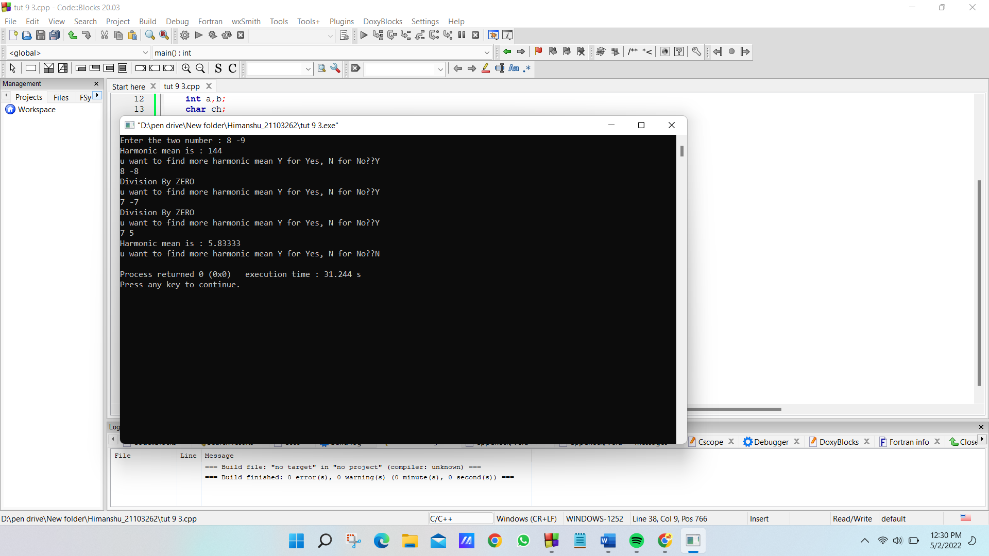

***4.*** *Predict the output of the following program:*

*#include<iostream>*

*using namespace std;*

*void callFunction(int i)*

*{*

*if(i)*

*throw 1;*

*else*

*throw 0;*

*}*

*void callFunction(char *n)*

*{*

*try{*

*if(n)*

*throw "StringOK";*

*else*

*throw "StringError";*

*}*

*catch(const char *name)*

*{*

*cout<<"catch "<<name<<"\n"; }*

*}*

*int main()*

*{*

*int i=1;*

*try*

*{*

*callFunction("teststring");*

*callFunction(0);*

*if(i)*

*{*

*throw "1";*

*}*

*else*

*{*

*throw "0";*

*}*

*}*

*catch(int i)*

*{*

*cout<<"catch 1 "<<i<<"\n";*

*}*

*catch(const char *name)*

*{*

*cout<<"catch 2 "<<name<<"\n"; }*

*}*

***Solution:***

*catch StringOK*

*catch 1 0*

***5.*** *What is the output of the program?*

*#include <iostream>*

*using namespace std;*

*int main()*

*{*

*try*

*{*

*throw 'a';*

*}*

*catch (int param)*

*{*

*cout<< "intexceptionn";*

*}*

*catch (...)*

*{*

*cout<< "default exception\n";*

*}*

*cout<< "After Exception";*

*return 0;*

*}*

***Solution:***

*default exception*

*After Exception*

***6.*** *What is the output of following code? Give a proper justification*

*#include <iostream>*

*using namespace std;*

*int main()*

*{*

*int x = -1;*

*try*

*{*

*if (x < 0)*

*{*

*throw x;*

*}*

*else*

*{*

*cout<<x;*

*}*

*}*

*catch (int x )*

*{*

*cout << "Exception occurred: Thrown value is " << x << endl;*

*}*

*return 0;*

*}*

*a) -1*

*b) 0*

*c) Exception occurred: Thrown value is -1*

*d) Error*

***Solution:***

*Answer: c*

*Explanation: As the given value is -1 and according to the condition, We are arising an exception.*

***7.*** *Which of the following statements are true about Catch handler?*

*i) It must be placed immediately after try block T.*

*ii) It can have multiple parameters.*

*iii) There must be only one catch handler for every try block.*

*iv) There can be multiple catch handler for a try block T.*

*v) Generic catch handler can be placed anywhere after try block.*

*A. Only i, iv, v*

*B. Onlyi,ii,iii*

*C. Onlyi,iv*

*D. Onlyi,ii*

***Solution:***

*Answer : c*